Educational Academy for Boys & Girls
35 Midland Avenue
Columbus, Ohio 43223
(IRN 000779)

ANNUAL REPORT
2021-2022

Students at Educational Academy for Boys & Girls (EABG) kept pace with National cohorts with respect to academic growth, as measured by NWEA norm-referenced assessments. Learning loss continues to be evident in comparing the the results of the Ohio State assessments with previous years. Strategies to deal with learning loss included an early start to the 2021-22 academic year. Notwithstanding, EABG achieved a 1 point increase in its Performance Index compared to the previous year.

The enrollment and academic performance of EABG showed steady growth as the school aims to “Make a World of Difference” to its students, families and community. Our focus is on preparing each student for 21st Century career readiness with a concentration on English Language Arts and Mathematics using a rigorous College-Preparatory curriculum. This program allows for our students to gain experience in the latest technological advances in instructional methods, including Newline interactive projection monitors and portable computer labs. We are proud that our multicultural student body has thrived and that the students outperform neighboring public schools significantly on achievement tests. We welcome you to come tour our school to observe the outstanding teaching and learning that takes place daily.

Mission: To make a “World of Difference” in the lives of our students by utilizing evidence-based education practice within an environment high in morals, social standards and care; measured by academic growth metrics.

Vision: To prepare students academically, socially and morally to become effective contributors to society with a focus on Real World Learning and career exploration.

Demographic Data
Enrollment

During the 2021-2022 school year, Educational Academy for Boys & Girls had a total of 133 students

Students enrolled in grades K-5 as follows:

Grade K 27

Grade 1st 22

Grade 2nd 24

Grade 3rd 17

Grade 4th 24

Grade 5th 19

Composition
Black 5 %
White 1 %
Multiracial 5 %
Hispanic 89 %

Economically Disadvantaged 100 %
Students with Disabilities 7 %

EDUCATIONAL PHILOSOPHY

Educational Academy for Boys and Girls is committing to the following:

- Providing a safe, caring and disciplined learning environment.
• Accepting no excuses for any child's failure to learn.
• Expecting and teaching all students to exhibit exemplary behavior.
• Emphasizing academic basics, especially in primary grades.
- Emphasizing only high student achievement based on rigorous, meaningful standards measured frequently (daily).
• Utilizing evidence-based curricula and instructional techniques.
- Employing a mastery model of learning in all academic areas to promote skill generalization.
• Treating parents as customers.
• Freeing teachers from inefficiencies and equipping/coaching them to teach all students to high levels of academic success.
- Utilizing the latest advances in technology.

The educational philosophy of the program states that every child can learn if taught appropriately. In other words, children who fail have been failed by the instruction to which they have been submitted. Equipped with a proven curriculum, school staff must follow successful instructional practices, evaluate each child each day, and as needed, alter ineffective teaching practices to meet the needs of every child. The school will emphasize basic skill development and mastery at every stage to make it most probable that skills will be applicable and generalizable beyond the immediate instructional setting.
EABG Financial Plan:
Total Operating Revenues $1,524,915
Total Operating Expenditures $1,589,817
Non Operating Revenues $561,945
Beginning Cash $107,930
Ending Cash $504,972

Academic Assessment and Accountability: 81% of EABG students are English Learners. With the support of our 100% highly qualified teachers and research-proven curricula, our students continue to meet projected yearly gains. EABG continuously focuses on advancing our students to the next academic level and utilize best practices to accomplish these aims. Through ongoing benchmark and MAP interim assessments, students exceeded or met projected growth targets in Reading and Math scores in most grades (Figure 1 below). We are pleased with the hard-fought academic gains achieved at EABG, and accept the COVID-related challenges to address learning loss.

Figure 1: = Expected academic gains for the respective grade cohort-Fall 2021 to Spring 2022 MAP Assessments.

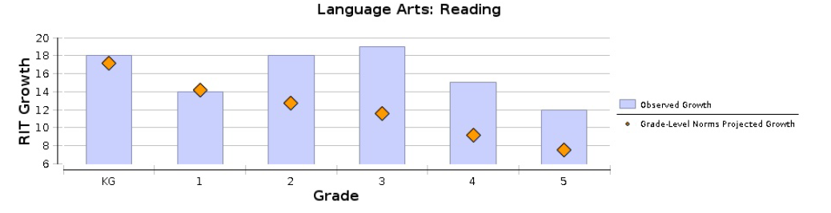
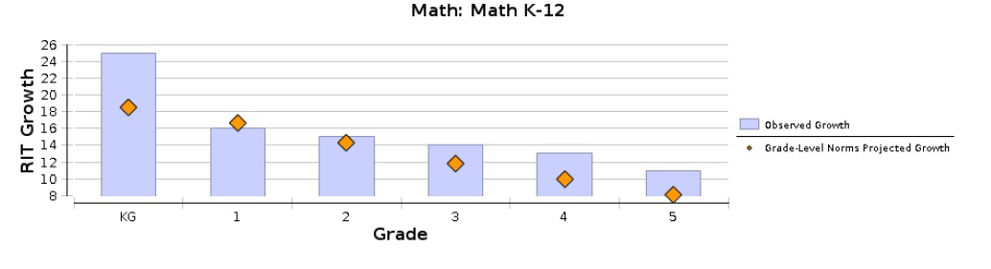
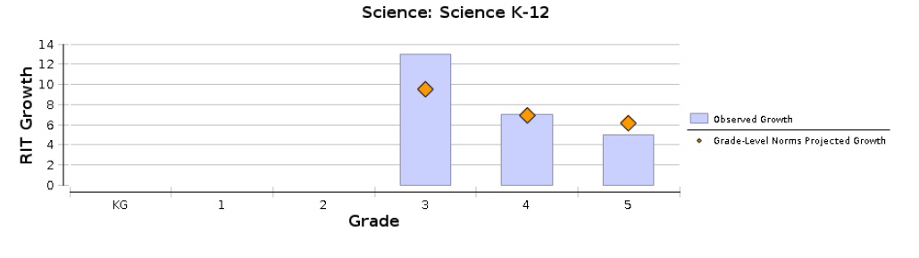

2021-2022 STATE OF OHIO ASSESSMENTS
Grade | Subject | Percent proficient
3 | Reading | 18
 | Math | 38
4 | Reading | 31
 | Math | 44
5 | Reading | 43
 | Math | 14
 | Science | 14

Governance: – The Five member Governing Board of EABG:
- Gloria Anderson
- Louis Morgan
- Paula Parlett
- Dr. Kenny Roman
- Shonen Thomas

Program Location:
35 Midland Avenue,
Columbus, OH 43223

